Partner Promotion Toolkit
for
Recommendations on Increasing the Uptake of Shared Decision-Making in Integrated Behavioral Health Care
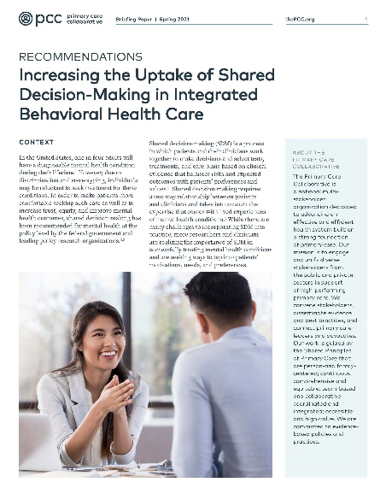
PCC has produced a new set of recommendations on increasing the uptake of shared decision-making (SDM) in behavioral health care that is integrated with primary care. The recommendations are the product of a 2020-2021 PCC project funded by a Eugene Washington PCORI Engagement Award for Community Convening.

SDM is much less prevalent in the behavioral health space as compared to medical settings. This can limit patients’ ability to be engaged in decisions about their care and may contribute to patient mistrust and poorer behavioral health outcomes.
PCC undertook this project to bring its learnings about SDM in the medical realm to integrated behavioral health settings and to leverage the expertise and backgrounds of leaders within our membership and in the broader primary care community.
PCC began this effort by reviewing the existing research literature at the intersection of primary care and behavioral health. PCC produced a summary of 80 articles on SDM in integrated care. PCC then assembled and hosted a roundtable of expert leaders from diverse stakeholder groups that leveraged our relationships in both behavioral health and primary care as well as our knowledge of how to engage patients and clinicians in shared decision-making. The roundtable reviewed the evidence summary before its gathering, which informed its four recommendations:
- Shift the culture to support SDM in all aspects of care to increase equity and reduce stigma.
- Build on the existing primary care infrastructure and learnings and enhance training.
- Advocate for prospective payment models that incorporate SDM, beginning with a shared definition and related measures.
- Further develop the SDM evidence base as it relates to outcomes, experience of care, and satisfaction.
We hope you, as an organization working to further more comprehensive primary care, including behavioral health integration, will promote these new recommendations with your staff, members and networks.

This toolkit provides sample elements for promoting the recommendations. While the promotional text items are ready to use, they may be edited lightly as necessary (with no permission from PCC required) according to your audience and communications channel. Please try to keep the core message intact, since our messaging is more effective when it’s consistent and repetitive.

If you have any questions or need further assistance, contact:

Stephen Padre
PCC’s Sr. Communications Manager
spadre@thepcc.org
202-417-3911

RESOURCES

- Sample newsletter/email/website copy (provided below)
- Sample social media posts (provided below)
- Landing page for the recommendations: www.pcpcc.org/resource/SDMrecs
- Recommendations in a PDF: bit.ly/SDMrecsPDF
- Recommendations on the web: bit.ly/SDMRecsweb
- Infographic of recommendations (one-page PDF summary): www.pcpcc.org/sites/default/files/resources/PCC Shared Decision-Making Recommendations Infographic.pdf
- Recording of June 16 webinar on the recommendations: available at www.pcpcc.org/webinars

SAMPLE NEWSLETTER/EMAIL/WEBSITE COPY

Primary Care Collaborative Develops Recommendations on Shared Decision-Making in Integrated Behavioral Health Care

The Primary Care Collaborative (www.pcpcc.org) (PCC) has produced a new set of recommendations (www.pcpcc.org/resource/SDMrecs) on increasing the uptake of shared decision-making (SDM) in settings where primary care and behavioral health are integrated. The recommendations, presented in a briefing paper, are the product of a 2020-2021 PCC project (www.pcpcc.org/increasing-uptake-shared-decision-making-behavioral-health) funded by a Eugene Washington PCORI Engagement Award for Community Convening (www.pcori.org/engagement/eugene-washington-pcori-engagement-awards).
SDM is much less prevalent in the behavioral health space as compared to medical settings. This can limit patients’ ability to be engaged in decisions about their care and may contribute to patient mistrust and poorer behavioral health outcomes.
PCC undertook this project to bring its learnings about SDM in the medical realm to integrated behavioral health settings and to leverage the expertise and backgrounds of leaders within our membership and in the broader primary care community.
PCC began this effort by reviewing the existing research literature at the intersection of primary care and behavioral health. PCC produced a summary of 80 articles on SDM in integrated care. PCC then assembled and hosted a roundtable of expert leaders (www.pcpcc.org/content/sdm) from diverse stakeholder groups that leveraged our relationships in both behavioral health and primary care as well as our knowledge of how to engage patients and clinicians in shared decision-making. The roundtable reviewed the evidence summary before its gathering, which informed its recommendations:
- Shift the culture to support SDM in all aspects of care to increase equity and reduce stigma.
- Build on the existing primary care infrastructure and learnings and enhance training.
- Advocate for prospective payment models that incorporate SDM, beginning with a shared definition and related measures.
- Further develop the SDM evidence base as it relates to outcomes, experience of care, and satisfaction.
Read/download the recommendations and related resources at www.pcpcc.org/resource/SDMrecs

About the Primary Care Collaborative:

Founded in 2006, the Primary Care Collaborative (PCC) is a nonprofit multi-stakeholder membership organization dedicated to advancing an effective and efficient health system built on a strong foundation of primary care and the patient-centered medical home. Representing a broad group of public and private organizations, PCC’s mission is to unify and engage diverse stakeholders in promoting policies and sharing best practices that support growth of high-performing primary care and achieve the “Quadruple Aim”: better care, better health, lower costs, and greater joy for clinicians and staff in delivery of care.

SAMPLE SOCIAL MEDIA POSTS
Twitter

General message/post aimed at general audiences

.@pcpcc has developed recommendations on increasing #shareddecisionmaking (SDM) in integrated #primarycare-#behavioralhealth settings, including shifting the culture to support SDM and moving to prospective payment models that incentivize SDM. www.pcpcc.org/resource/SDMrecs

Post aimed at patient advocates

How can advocates help patients participate more in #shareddecisionmaking (SDM) in integrated #primarycare-#behavioralhealth settings? @PCPCC has developed new recommendations on increasing SDM, such as creating educational materials for patients: www.pcpcc.org/resource/SDMrecs

Post aimed at clinicians

How can clinicians use #shareddecisionmaking (SDM) more in integrated #primarycare-#behavioralhealth settings? @PCPCC has developed new recommendations, such as asking patients, “What matters to you?” rather than “What’s the matter with you?” www.pcpcc.org/resource/SDMrecs

Post aimed at policymakers

How can policymakers encourage more #shareddecisionmaking (SDM) in integrated #primarycare-#behavioralhealth settings? One way: adequately invest in primary care so practices can integrate behavioral health & engage in SDM. Get the recommendations: www.pcpcc.org/resource/SDMrecs

Facebook

General message/post aimed at general audiences

The Primary Care Collaborative has produced a new set of recommendations on increasing the use of shared decision-making (SDM) in settings where primary care and behavioral health are integrated. The recommendations include shifting aspects of the behavioral health culture to support SDM and moving to prospective payment models that incentivize the use SDM. Get the recommendations at www.pcpcc.org/resource/SDMrecs

Post aimed at patient advocates

The Primary Care Collaborative has developed a new set of recommendations on increasing the use of shared decision-making in settings where primary care and behavioral health are integrated. One way for patient advocates to put the recommendations into action is to create infographics or other educational materials to help patients understand how to ask questions, get involved, and be co-producers in a behavioral health visit. Get the recommendations at www.pcpcc.org/resource/SDMrecs

Post aimed at clinicians

The Primary Care Collaborative has developed a new set of recommendations on increasing the use of shared decision-making in settings where primary care and behavioral health are integrated. One way for clinicians to put the recommendations into action is to cultivate a culture shift in your work by asking patients, “What matters to you?” rather than “What’s the matter with you?” Get the recommendations at www.pcpcc.org/resource/SDMrecs

Post aimed at policymakers

The Primary Care Collaborative has developed a new set of recommendations on increasing the use of shared decision-making (SDM) in settings where primary care and behavioral health are integrated. One way for policymakers to put the recommendations into action is to adequately invest in primary care so practices can integrate behavioral health and engage in SDM. Get the recommendations at www.pcpcc.org/resource/SDMrecs

