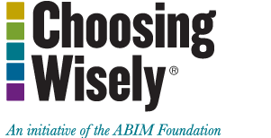
Additional Resources

Materials for Patients:
http://www.choosingwisely.org/getting-started/resource-library/additional-materials-for-patients/
Implementing Choosing Wisely in Rural Communities
Bagging Antibiotics in Maine
Making Choosing Wisely Count for More

